**CS120 Fundamental of Programming**

**Lab No. 2: Programs Using Variables, Operators, Expressions**

**Practice Exercises**

1. Write a program that declares several int and float variables, without initializing them, and then prints their values. Is there any pattern to the values?

#include <stdio.h>

int main()

{

int a, b;

float c, d;

printf("a = %d, b = %d\n", a, b);

printf("a = %f, b = %f\n", c, d);

system("pause");

return 0;

}

1. Write a program to compute and display the volume of a cylinder with following measurements.

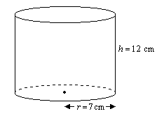

where volume v=πr2h

Hint: r2 = r*r , π = 22/7.

#include <stdio.h>

int main()

{

int r = 7, h = 12;

float pi = 22.0/7;

float volume;

volume = pi * r * r * h;

printf("Volume of cylinder is : %.2f", volume);

system("pause");

return 0;

}

1. Write a program that converts the days to Weeks and Days. For example, if the number in days is 24, the output will be : 3 Weeks 3 Days [Hint: Use modulus operator]

#include <stdio.h>

int main()

{

int days;

printf("Enter number of days : ");

scanf("%d", &days);

printf("%d days have %d weeks and %d days\n", days, days/7, days%7);

system("pause");

return 0;

}